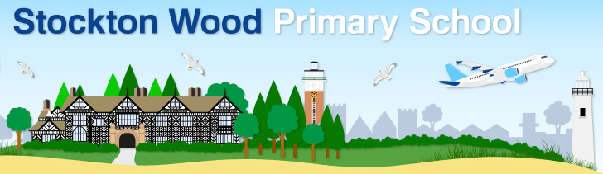
Wider Opening of School Update: Use of Entrances and Exits on Site for KS2
Dear Parents,
From Monday, 29th June, more children will be returning to school which means we need to change how we manage the movement of children around the school site.
All eligible KS2 children should now use the Stockton Wood Road entrance/exit. This allows us to manage the movement of children and adults on the school site and reduce mixing of groups of children.

KS2 children will be met at the Stockton Wood Road entrance by staff and directed to their classroom.

KS2 parents must not enter the school site. If accompanying your child to school please say, ‘Goodbye’ at the school gate and disperse quickly.

KS2 children will be dismissed by staff from Stockton Wood Road school gate at end of day. If collecting your child from school again please disperse quickly at the end of the day.

Exception: If you have a KS2 child with an infant sibling, they may arrive with their sibling and make their way to their classroom. At the end of the day they will be dismissed with their sibling. Again staff will be ready to assist on site.

Arrangements for Year 3, 4 and 5 children
Entrance/Exit | Start time | Finish time
Stockton Wood Road | 9.10am | 3.15pm

Arrangements for Year 6 children
Entrance/Exit | Start time | Finish time
Stockton Wood Road | 9.20am | Mon to Thurs: 3.20pm  Friday: 2.45pm

Don’t forget everybody has a part to play to help us make our school as safe as possible. Our COVID Safe Procedures must be followed. An updated copy is attached please read carefully.

By sending your child to school during this period, you are agreeing to follow our COVID Safe Procedures.

Thank you for supporting our COVID Safe Procedures.
Yours sincerely,
S.E.Price
Head teacher
25.6.20

