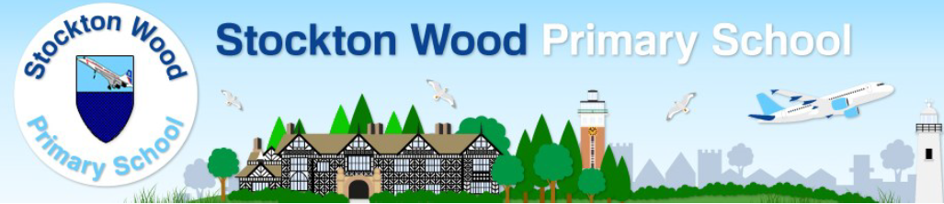
Nursery Curriculum Overview 2025-2026
Area of Learning | Autumn Term 1 | Autumn Term 2 | Spring Term 1 | Spring Term 2 | Summer Term 1 | Summer Term 2
PSED | SCARF: Me & My Relationships | SCARF: Valuing Difference | SCARF: Keeping Myself Safe | SCARF: Rights & Responsibilities | SCARF: Being My best | SCARF: Growing & Changing  Transition to Y1
Physical Development | Fine and gross motor skills
Communication & Language | Each half term (ongoing):  - Vocabulary relating to current topic  - Use new vocabulary through the day  - Engage in story times  - Develop social phrases  - Understand why listening is important  - Describe topics in detail
Literacy:  Fiction | The Gingerbread Man  (Heather Has Two Mummies) | The Elves and the Shoe Maker | The 3 Little Pigs | The Enormous Turnip | Jack and the Beanstalk | The Ugly Duckling
Literacy:  Non-fiction | - Diverse families books  - Friendship books  - Autumn books | - Autumn/winter books (inc. animals that hibernate)  - Multi-faith books  - Celebrations books such as Diwali, Halloween, Bonfire Night, Christmas | - Winter books (inc. Arctic & Antarctic animals)  - Transport books  - Chinese New Year | - Growth/spring books | - Minibeast information books  - Spring & Growing books  - Farm animals books | - Wild animals books  - Summer books
Role Play | Home corner | Home corner  Santa’s Workshop | Home corner  Chinese New year | Home corner  Birthday party | Home corner  Farm | Home corner
Mathematics | - Colour/Matching/Sorting  - Number 1 and 2  - Pattern |  | - Number 3, 4, 5, and 6  - Height/Length  - Mass  - Capacity |  | - Sequencing  - Positional Language  - More than/fewer than  - Shape 2D/3D  - Number composition
Mathematics | Ongoing: Number, counting, subitising, comparing numbers
Lifesavers | Milo’s Money | Milo’s Money | Milo’s Money | Milo’s Money | Milo’s Money | Milo’s Money
Knowledge & Understanding of the World | - Myself & My Body  - Hallowe’en | - Seasons: Autumn (inc. Autumn Walk)  - Bonfire Night  - Christmas  - Diwali  - Hannukah | - Seasons: Winter  - (inc. Winter Walk)  - Ice/freezing/  - melting  - Chinese New Year  - Holi | - Pancake Tuesday  - Lent  - Mother’s Day  - Easter  - Plant beans | - Seasons: Spring  - (inc. Spring Walk)  - Baby animals  - Farm animals (habitats)  - Minibeast hunting | - Seasons: Summer  - (inc. Summer Walk)  - Wild animals (habitats)
Expressive Art & Design | - Painting / Colour Mixing  - Singing  - Nursery rhyme of the week | - Printing  - Singing  - Nursery rhyme of the week  - Halloween crafts  - Christmas cards, calendars & decorations  - Leaf rubbing and Autumn collages  - Christmas songs | - Collage / Textures  - Singing  - Nursery rhyme of the week  - Chinese music & dragon dance  - Chinese New Year crafts  - Valentines Cards | - Observational drawing  - Singing  - Nursery rhyme of the week  - Easter cards & baskets  - Mother’s Day cards | - Singing  - Nursery rhyme of the week  - Construction: building a farm/stables/pens | - Singing  - Nursery rhyme of the week  - Construction: building a zoo/enclosures

