10th June 2022
Dear Parents/Carers
I hope you all had a lovely half term and feel refreshed for the last weeks of the summer term.
New school website
Our new school website should be ‘live’ from Tuesday 14th June! I hope that you will find it easy to navigate. You will be able to see information about your child’s year group; curriculum information; policies; upcoming events and news. Our Twitter account is directly linked too, so you will be able to see any activities that we share. We will be developing our website further over the next few weeks so please do keep checking for updates.
Parent’s Group
Our next Parent’s Group meeting will be Wednesday 15th June at 9:05 am. Please do come and have a ‘cuppa and catch up’.
Parental Involvement
We are keen to invite parents in to school during this half term. Each class will be asking parents/carers to join them for an activity – this could be for a cookery activity, a sing-a-long or a quiz. Separate letters will be sent home with specific dates and times.
Old Reading Books
We have had a big tidy in preparation for our new reading scheme! As a result, we have a lot of wonderful books looking for a new home. We will be having a ‘pre-loved’ book sale in school next Thursday 16th June. Smaller books will be 10p and we have some larger books for £1.
Important reminder from Mrs Jackson:
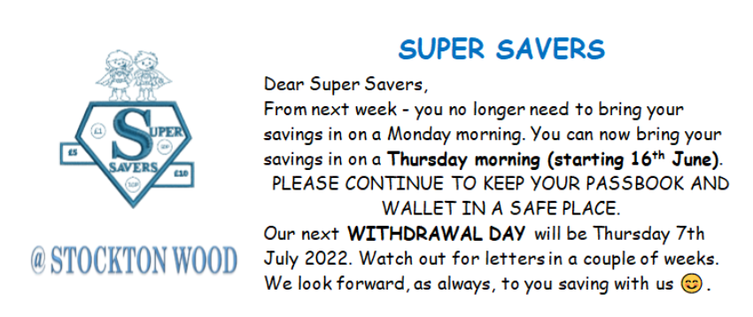

New Aldi Store – Speke Road
The new Aldi store have been in touch with us. Not only have they asked us to take part in the official opening on June 30th, they have also arranged a GB athlete to come to school and deliver a special assembly. Also, they have an exciting competition that they would like us to be involved in:
Children’s Poster Competition – Win £20!

We would like to invite your pupils to take part in a poster drawing competition. The poster should be a picture of ‘what healthy eating means to you’. The lucky winner will receive a £20 gift voucher to spend at the new Aldi store. We will bring the voucher with us on 30th June to present to the winner on the day, along with a donation of fresh fruit and vegetables.

Teachers will send home A4 paper for competition entries. Please return them to school by WEDNESDAY 29TH JUNE.
Reminder: Additional Inset Day – Friday 17th June
The local authority have approved an additional training day for ‘Read Write Inc’ training. This will be a new phonics and reading scheme that will be introduced for our children in Reception – Year 2 in late June. Parents will receive guidance on how the scheme works nearer the time.
Dates for your diary:
Monday 4th July: Sports Day KS2 2:15pm
Tuesday 5th July: Sports Day KS1 2:15pm
Friday 15th July: Prize Giving KS1 9:15am and KS2 2pm
(Dates for EYFS sports day to follow)
Thursday 14th July: Y6 Beach Party
Monday 18th July: Y6 Leavers’ Assembly 2pm
Tuesday 19th July: Break up for summer
Thank you,

J L Clovis
Headteacher

