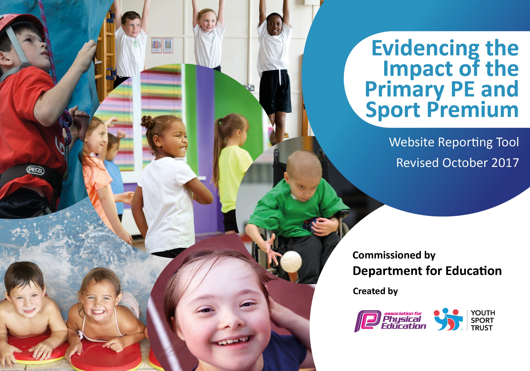

Schools must use the funding to make additional and sustainable improvements to the quality of PE and sport they offer. This means that you should use the Primary PE and Sport Premium to:

- develop or add to the PE and sport activities that your school already offers
- build capacity and capability within the school to ensure that improvements made now will benefit pupils joining the school in future years

Please visit gov.uk for the revised DfE guidance including the 5 key indicators across which schools should demonstrate an improvement. This document will help you to review your provision and to report your spend. DfE encourages schools to use this template as an effective way of meeting the reporting requirements of the Primary PE and Sport Premium.

We recommend you start by reflecting on the impact of current provision and reviewing the previous spend.
Under the Ofsted Schools Inspection Framework, inspectors will assess how effectively leaders use
the Primary PE and Sport Premium and measure its impact on outcomes for pupils, and how effectively governors hold them to account
for this.

Schools are required to publish details of how they spend this funding as well as on the impact it has on pupils’ PE
and sport participation and attainment.
We recommend regularly updating the table and
publishing it on your website as evidence
of your ongoing review into how you are using the money
to secure maximum, sustainable impact. To see an example of how to complete the table please click _{HERE}.

Support for review and reflection - considering the 5 key indicators from DfE, what development needs are a priority for your setting and your students now and why? Use the space below to reflect on previous spend, identify current need and priorities for the future.

Key achievements to date: | Areas for further improvement and baseline evidence of need:
- School Games Quality mark achieved annually supporting our commitment to provide a range of quality physical activity and competitive sports. We achieved Gold standard in 2016, Silver standard in 2017 and are working towards achieving Gold standard for this academic year.  - Individual sporting achievements recognised and celebrated through assemblies. eg Triathlon, Cross country, Gymnastics, Swimming etc.  - Winners at City Finals playing New Age Kurling. This competition was for SEND children, ensuring that there is opportunity for all pupils to participate in sport.  - SEND children Representing Liverpool at the Merseyside School Games in July 2018 participating in Kurling.  - Increased our participation levels in competitive sports and events to support our School Games Award.  - Improved outcomes at end of KS2 for the national expectation of 25 metres swimming standard over last two years. In 2016, 88% of our children achieved the expected standard and in 2017, 91% of children achieved the standard.  - School Inter House sporting competition and School Termly Block Race for KS2 (achievement of personal best).  - Participation in community sporting events eg Winners of Beat the Street, Rock and Roll Marathon and Go Run for Fun.  - Breakfast club is well attended providing a healthy and active start to school day. Approximately 50 (35%) children attend daily from KS2 and a targeted group of children from KS1. Breakfast club is also provided for EYFS children from 8.30am. | - CPD for teaching staff to enhance and support planning for progression for core PE.  - CPD for Gymnastics. This has been identified as the next key topic for staff development.  - Possible purchase of new scheme of work to support progression of skills. Currently using LCP. Schemes being considered include Real PE and Get Set 4 PE.  - Purchase and replenish resources as required to support lesson delivery and extra- curricular activities.  - Widen extra-curricular sporting opportunities through the use of outside agencies.  - Further extend sporting community links – Rock and Roll Marathon, Speke Hall Park Run, Austin Rawlinson Leisure Centre.  - Provide additional opportunity for Pupil voice - ensure systems are in place to allow pupils to share their views on after-school clubs that they would like and share outcomes of active playtimes.

Meeting national curriculum requirements for swimming and water safety | Please complete all of the below:
What percentage of your Year 6 pupils could swim competently, confidently and proficiently over a distance of at least 25 metres when they left your primary school at the end of last academic year? | 91%
What percentage of your Year 6 pupils could use a range of strokes effectively [for example, front crawl, backstroke and breaststroke] when they left your primary school at the end of last academic year? | 52%  All effective at front crawl and backstroke, breaststroke required development.
What percentage of your Year 6 pupils could perform safe self-rescue in different water-based situations when they left your primary school at the end of last academic year? | 91% (pool based and lake at PGL)
Schools can choose to use the Primary PE and Sport Premium to provide additional provision for swimming but this must be for activity over and above the national curriculum requirements. Have you used it in this way? | Yes  Year 6 Top up sessions  Additional swimming sessions for Year 4 and Year 3

Action Plan and Budget Tracking
Capture your intended annual spend against the 5 key indicators. Clarify the success criteria and evidence of impact that you intend to measure to evaluate for students today and for the future.

Academic Year: 2017/18 | Total fund allocated: £1870 | Date Updated: Jan 2018
Key indicator 1: The engagement of all pupils in regular physical activity – Chief Medical Officer guidelines recommend that primary school children undertake at least 30 minutes of physical activity a day in school |  |  |  | Percentage of total allocation:
 |  |  |  | 20%
School focus with clarity on intended impact on pupils: | Actions to achieve: | Funding allocated: | Evidence and impact: | Sustainability and suggested next steps:
To increase and enhance physical activity levels of all pupils by purchasing Maths of the Day to support delivery of Fitness and Agility sessions, alongside Rise and Shine and 5 a Day.  To ensure all pupils get at least 15 minutes of physical activity each day,  introduce Daily Mile to improve fitness, stamina, health and wellbeing. Improve concentration in lessons thus impacting on attainment.  Increase activity levels in the playground through Young Play Leaders training, in order to engage more pupils in active playtimes.  Purchase of additional playground equipment to increase active play for pupils and enhance teamwork and co-operation.  Make other areas of the curriculum more active for all pupils through the use of BBC Super Movers to support active learning in English and Maths. | Active weekly Maths lesson planned for all children.  Enjoyment and engagement for all.  Contribute to raising attainment in Maths through active engagement.  Targeted intervention using Maths of the Day across the school to raise standards in Maths for some children.  All children and staff to be active for 15 minutes every day.  Staff meeting to explain philosophy of Daily Mile and embed provision.  Young Play leaders to support running groups.  Markings of routes for KS1 and KS2.  Training from LSSP for Young leaders. Purchase of additional playground equipment.  Year 3 and 4 (16 chd)  Year 5 and 6 (16 chd)  Audit and replenish termly.  Raise awareness of resource through staff meeting. | £570  £1000 approx  2x 1 hour sessions for  Year 3 and 4 £225  2x 1.5 hour session for Year 5 and 6 £225  £1000 | Monitoring of planning by Maths lead to ensure resource is being used consistently.  Feedback from staff as to usefulness of resource.  Photographic evidence of children participating in Maths of the Day activities. (Display)  Use attainment data to evaluate progress in Maths of target groups of children.  Improved fitness, health and wellbeing. Children to keep tally of laps achieved. Certificates awarded for motivation.  Track children’s achievements to measure impact.  Increased participation in organised games at playtimes.  Social skills improved amongst peer groups.  Pupils confidence levels improved and they feel valued as leaders.  More pupils willing to lead organised games.  Children involved in active playtimes. Reduced incidents of unacceptable behaviour both outside and inside school.  Teacher feedback though tracker sheet, monitored by Learning Mentor.  Pupils ready to learn during the morning/afternoon curriculum (teacher feedback).  Staff using resource regularly to engage children in active learning.  Increased concentration and raised attainment. Kinesthetic learning opportunities for all children. | Annual purchase of license.  Develop use through extra- curricular club for targeted children (least active)  Refresher training for staff including TA for future use as an intervention. (19.0418)  Part of school day  Link to British Heart Foundation ‘Marathon in May’ event.  Form links with City events: Park Runs and Rock and Roll Marathon.  Utilise the Schools Active Planner website to track activity.  Children trained and confident when organising games.  Young leaders monitor impact of activities and share with PE lead.  Children given a timetable for playtime activities.  Monitored by TA’s during play and lunchtime to evaluate impact.  Equipment monitors from Y2/Y6 to collect and store equipment. Lead Ta’s to monitor and inform PE lead when replenish required.  Next steps: training Y2 play leaders.  Free resource easy to sustain. Site to be further developed this year.  Teachers become more familiar with resources, greater impact on active learning.
Key indicator 2: The profile of PE and sport being raised across the school as a tool for whole school improvement |  |  |  | Percentage of total allocation:
 |  |  |  | 25%
School focus with clarity on intended impact on pupils: | Actions to achieve: | Funding allocated: | Evidence and impact: | Sustainability and suggested next steps:
To celebrate pupil success in PE lessons, sport and physical activity not just for performance but other life skills linked to the school games values of respect, teamwork, honesty, passion, self-belief and determination.  To raise the awareness of opportunities, the profile and the impact of physical activity and sport across the school and community with pupils & parents.  To ensure that there is additional opportunity for pupils to engage in competitive sporting events.  To evaluate and measure the impact of PE on children’s health, wellbeing and academic achievement.  To ensure the children receive quality first teaching during PE provision which is progressive, challenging and skill based. | Celebrate achievements using photographs, video footage and reports from competitions, events, PE Lessons, extracurricular activities, Young Leaders feedback and personal achievements outside of school. Showcase relevant displays linked to PE core units. Eg gym, dance.  IIP/School council reps to conduct a survey to find out the range of sports children participate in outside of school.  Sportsperson of the Week display introducing a variety of sports and athletes. Children research facts and add to display.  Survey of sporting talent and achievement.  Involvement in British Heart Foundation ‘Marathon in May’ event. Incorporate mile a day within core PE lessons. Regular running training available during lunchtime.  Membership of LSSP to support PE development and competitive opportunities.  Extra Curricular clubs providing a range of activities delivered by qualified coaches.  Staff CPD planned to support lesson planning and delivery.  Certificates awarded to all children who participate in school competitions.  PE lead to attend regular training events to keep up to date with current legislation and new initiatives.  PE lead to monitor plans, and observe teaching to evaluate quality of provision.  PE lead to deliver training on assessment of PE and monitor systems used.  PE lead to complete application for school games mark 2017-18 with Learning Mentor. | £1495 (Bronze level membership LSSP)  £1000 towards transport costs for competitions off site.  £250 CPD training for staff focusing on PE curriculum (gymnastics)  £1500 to cover cost of Extra -Curriculum clubs provided by sports coaches. | 100% of children in assemblies celebrating success.  End of Year school assembly for parents celebrating sporting achievements.  Regular newsletters and information on website linked to PE.  Increased knowledge of sporting activities and champions. Raised self-esteem and confidence of the children as their personal achievements are valued and recognised.  Children more aware of the importance of healthy and active lifestyles.  PE lead confident to drive the PE curriculum. Good understanding of role and implications.  Increased attendance and participation in LSSP competitions at both heat and city level.  School Games Award application as evidence of commitment to physical activity. | Links with local sport clubs further developed – Mersey Mavericks (basketball team)  Everton FC (link with Super Movers),Liverpool FC Kicks programme  Continue to buy into LSSP membership. Possibly up level membership to Silver to receive additional benefits.  Staff to Support extra-curricular clubs to develop skills and knowledge of specific sports.  PE lead and additional staff to measure impact and attendance at Extra-Curricular clubs.  Staff support extra-curricular clubs as part of CPD.

Key indicator 3: Increased confidence, knowledge and skills of all staff in teaching PE and sport |  |  |  | Percentage of total allocation:
 |  |  |  | 45%
School focus with clarity on intended  impact on pupils: | Actions to achieve: | Funding  allocated: | Evidence and impact: | Sustainability and suggested  next steps:
To provide all pupils with a high quality, progressive PE / School sport.  Children benefit from good quality first teaching which is differentiated to support their individual needs.  To increase the quality of the Extra-curricular clubs for our pupils through the use of trained PE specialists to ensure quality provision supported by Teachers/TA as part of CPD.  To provide the opportunity for more children to access additional swimming lessons provided by Liverpool Schools Swimming Programme. | PPA time to prepare for lesson delivery.  Staff attend training to improve confidence when delivering Gymnastics and ensure progression of skills.  Ensure all children have a weekly Core PE lesson and an additional Fitness and Agility session.  PE lead attends termly meeting with LA and LSSP and cascades  Information to colleagues through staff meetings.  The curriculum provides the development of key skills and the children are able to compete with other schools at a good standard.  Children encouraged to attend local clubs to further develop their talent.  Increase use of Sports coaches to deliver extra- curricular sessions to a wider range of pupils.  Weekly commitment of staff to support swimming lessons. Staff to be aware of progress of children.  Provide additional swimming sessions for children to ensure they feel safe and confident in water and continue to increase the percentage of achievement of the expected standard by the end of KS2. | £250 per session  Supply cover  £300 per term  £50 per session  £6 per child per session.  Total additional spend = £7251  Year 5: 12 sessions x 41 chd = £2952  Year 4: 31 sessions x 43chd = £7998  Year 3: 19 sessions x 27chd =£3078  Year 6 top up sessions x 5= £30 per child  Cost depends on numbers. | All children have at least 2hrs of physical activity per week.  Photographs collated of achievement in each aspect of core PE. Staff feedback on impact and progress of PE provision.  Assessment of PE carried out termly.  Pupil voice survey linked to enjoyment of Physical activity in school and extra- curricular opportunities.  By providing more than double the national average number (16) of swimming lessons per cohort, a huge emphasis is placed on our children achieving the expectations for swimming. One reason for this is that our children live in close proximity to waterways and the river and local beaches.  Last year 91% of our children at the end of KS2 achieved the swimming standard. Figures provided by LA through School Swimming Programme. | Resources purchased to support staff delivering PE.  Continue with CDP events as identified by staff.  Continue membership of LSSP  Possible use of Sports Apprentices to support delivery of PE curriculum.  Ensure School Swim Programme meets the requirements of the National Curriculum as identified.  Attend swimming Galas and water polo events.
Key indicator 4: Broader experience of a range of sports and activities offered to all pupils |  |  |  | Percentage of total allocation:
 |  |  |  | 10%
School focus with clarity on intended  impact on pupils: | Actions to achieve: | Funding  allocated: | Evidence and impact: | Sustainability and suggested  next steps:
Continue to offer a wider range of activities both within and outside the curriculum in order to engage more pupils. Focus particularly on those pupils who do not take up additional PE and Sport opportunities.  To promote physical activity, confidence and Road safety for Year 5 pupils through Bikeability. | Audit and replenish core PE equipment. Purchase additional resources to increase range of sports available for children to experience including new netball/basketball posts and table tennis tables.  Provide additional playground equipment to be used by the Young Leaders for organised games.  Membership of LSSP ensures all children have wider access to more sporting opportunities, physical activity and competitions including Kwik sticks, Mini red tennis, Boccia, NAK ect.  Outdoor adventure activities at PGL.  Forest school and school grounds used to support active learning.  Extra –Curricular clubs and competitions to provide further opportunity for pupils.  Bikeability provided in Y5 to ensure all pupils can ride a bike and know about the safety elements of riding in the4 community | £1000 | Increased participation in school sports.  Raised awareness of health and fitness through curriculum.  Evidence provided by Bikablility of achievement and certificates presented. | Continue to develop extra –curricular clubs and lunchtime activities.  Use of TA’s and Young leaders to direct and organize active play.  Continue to offer Bikeability to Year 5. Introduce Balanceability in EYFS and KS1  Use additional LSSP programmes to enhance range of clubs– Dunk the Junk, POWER programme, Change 4 Life Club.
Key indicator 5: Increased participation in competitive sport |  |  |  | Percentage of total allocation:
School focus with clarity on intended  impact on pupils: | Actions to achieve: | Funding  allocated: | Evidence and impact: | Sustainability and suggested  next steps:
To allow all children to have the opportunity to take part in competitive sport at school and against other schools. | PE lead to book, risk assess and organise all sporting events out of school.  Network with local schools to arrange competitions and through LSSP.  All pupils in KS2 participate in Block Race to achieve their personal best.  Annual Sports day for all children.  Link Extra-Curricular clubs to future competition events  Target a range of children to participate in a range of physical activities. | Funding allocated previously identified. | Children to further develop self esteem through success.  Celebrate achievement through assemblies, newsletter, website and certificates.  School games data for KS2 participation  School games values awards achieved at competition. | Strive to achieve and maintain Gold standard of School Games Mark.  Increase range of personal challenges – school council, young leaders ideas engage less active low confidence KS1  Balanceability EYFS KS1  Achievement of the KS1 LSSP award to increase the opportunity of participation in competitive sports and celebration events.

Total spending for PE = £17,866 excluding Year 6 Top Up Swimming and purchase of medals for Sports day.

