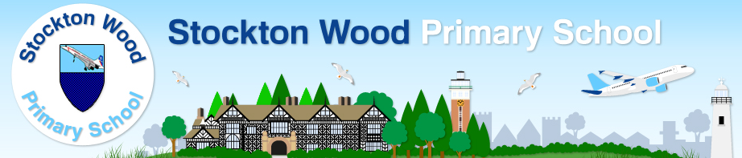

Restorative Practice @ Stockton Wood

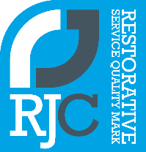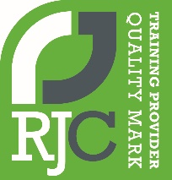

**Restorative Practice – Statement of Intent**

We promote restorative practice at our school.

The aim of Restorative Practice is to develop community and to manage conflict and tensions by repairing harm and building relationships. This is our priority as a restorative school, as we see ourselves at the heart of and serving our community.

It is a process that puts repairing harm done to relationships and people over and above assigning blame and dispensing punishment. It shifts the emphasis from managing behaviour to focussing on building, nurturing, and repairing relationships.

For effective teaching and learning to take place, we believe that good relationships need to be at the heart of everything that happens at Stockton Wood Primary School.

Restorative Practice complements and supports the implementation of our Behaviour Policy.

**Our school RP Values chosen by our school community:**

* Friendship
* Love
* Kindness
* Fun
* Respect

**We use RP Questions to help us manage and repair relationships:**



We know that a whole-school restorative approach can contribute to:

•Happier and safer schools

•Mutually respectful relationships

•More effective teaching and learning

•Reduced exclusions

•Raised attendance

•Reduction in bullying behaviour

•Raised morale and self-esteem

•A culture of inclusion and belonging

•Increased emotional literacy